Preparation of Papers for
the REHVA Student Competition
First Autor(s)

Abstract—These instructions give you basic guidelines for preparing camera-ready papers for the REHVA student competitions proceedings. Use this document as a template if you are using Microsoft Word 6.0 or later. Otherwise, use this document as an instruction set. The electronic file of your paper will be formatted further. Define all symbols used in the abstract. Do not cite references in the abstract.
Index Terms—About four key words or phrases in alphabetical order, separated by commas.
Introduction
This document is a template for Microsoft Word versions 6.0 or later. In the Introduction Section of your paper please include the identification and a short description of the studied subject, the framework for the work carried out, the motivation and the objectives. The paper should include, at least, the following main section besides the Introduction: Methods, Data Presentation and Discussion, Conclusions.

Full-Sized Camera-Ready (CR) Copy
Prepare your camera ready paper in full-size format, on A4 paper (210 x 297 mm).
Type sizes and typefaces: Follow the type sizes specified in Table I. As an aid in gauging type size, 1 point is about 0.35 mm. The size of the lowercase letter “j” will give the point size. Times New Roman is the preferred font.
- Type Sizes for Camera-Ready Papers
Type size (pts.) | Appearance
 | Regular | Bold | Italic
6 | Table captions, a table superscripts
8 | Section titles,a references, tables, table names,a first letters in table captions,a figure captions, footnotes, text subscripts, and superscripts
9 |  | Abstract
10 | Authors’ affiliations, main text, equations, first letters in section titlesa |  | Subheading
11 | Authors’ names
24 | Paper title
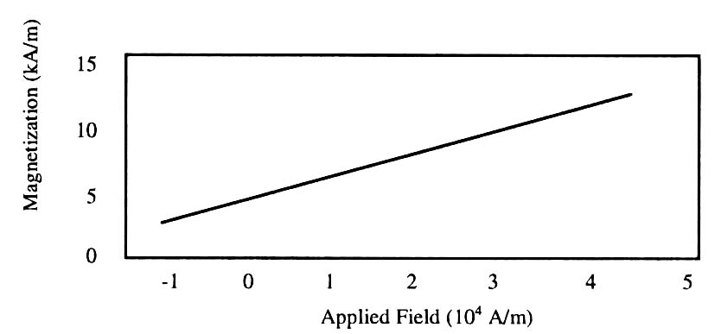
- Example of a figure legend. Note how the caption is centered in the column
Margins: top and bottom = 25mm, left and right = 20 mm.
The column width is 82mm (3.23 in). The space between the two columns is 6mm (0.24 in). Paragraph indentation is 3.5 mm (0.14 in).
Left- and right-justify your columns. Use tables and figures to adjust column length. On the last page of your paper, adjust the lengths of the columns so that they are equal. Use automatic hyphenation and check spelling. Digitize or paste down figures.

Helpful Hints

Figures and Tables
Embedding MS Visio drawings causes problems while transforming the document into PDF format. It is better to export them to GIF (graphics, screenshots) or JPEG (photos) format.
Position figures and tables at the tops and bottoms of columns. Avoid placing them in the middle of columns. Large figures and tables may span across both columns. Figure captions should be centered below the figures; table captions should be centered above. Avoid placing figures and tables before their first mention in the text. Use the abbreviation “Fig. 1,” even at the beginning of a sentence.
Figure axis labels are often a source of confusion. Use words rather than symbols. For example, write “Pressure,” or “Pressure, P,” not just “P.” Put units in parentheses. Do not label axes only with units. In the example, write “Pressure (Pa)”. Do not label axes with a ratio of quantities and units. For example, write “Temperature (K),” not “Temperature/K.”
Multipliers can be especially confusing. Write “Pressur (kPa)” or "Pressure (103 Pa).” Figure labels should be legible, about 10-point type.

References
Number citations consecutively in square brackets [1]. Punctuation follows the bracket [2]. Refer simply to the reference number, as in [3]. Use “Ref. [3]” or “Reference [3]” at the beginning of a sentence: “Reference [3] was the first ...”
Number footnotes separately in superscripts. Place the actual footnote at the bottom of the column in which it was cited. Do not put footnotes in the reference list. Use letters for table footnotes (see Table 1).
Give all authors’ names; use “et al.” if there are six authors or more. Papers that have not been published, even if they have been submitted for publication, should be cited as “unpublished” [4]. Papers that have been accepted for publication should be cited as “in press” [5]. In a paper title, capitalize the first word and all other words except for conjunctions, prepositions less than seven letters, and prepositional phrases.

Abbreviations and Acronyms
Define abbreviations and acronyms the first time they are used in the text, even after they have been defined in the abstract. Do not use abbreviations in the title unless they are unavoidable.

Equations
Number equations consecutively with equation numbers in parentheses flush with the right margin, as in (1). To make your equations more compact, you may use the solidus (/), the exp function, or appropriate exponents. Italicize Roman symbols for quantities and variables, but not Greek symbols. Use an en dash (−) rather than a hyphen for a minus sign. Use parentheses to avoid ambiguities in denominators. Punctuate equations with commas or periods when they are part of a sentence, as in
. (1)
Symbols in your equation should be defined before the equation appears or immediately following. Use “(1),” not “Eq. (1)” or “equation (1),” except at the beginning of a sentence: “Equation (1) is ...”

Other Recommendations
The Roman numerals used to number the section headings are optional. If you do use them, do not number Acknowledgments and References, and begin Subheadings with letters. Use two spaces after periods (full stops). Hyphenate complex modifiers: “zero-field-cooled magnetization.” Avoid dangling participles, such as, “Using (1), the potential was calculated.” Write instead, “The potential was calculated using (1),” or “Using (1), we calculated the potential.”
Use a zero before decimal points: “0.25,” not “.25.” Use “cm3,” not “cc.” Do not mix complete spellings and abbreviations of units: “Wb/m2” or “webers per square meter.” not “webers/m2.” Spell units when they appear in text: “...a few pascals,” not “...a few Pa.” If your native language is not English, try to get a native English-speaking colleague to proofread your paper.

Units
Use either SI (MKS) as primary units. English units may be used as secondary units (in parentheses). An exception would be the use of English units as identifiers in trade, such as “3.5-inch disk drive.”
Avoid combining SI and CGS units, such as current in amperes and magnetic field in oersteds. This often leads to confusion because equations do not balance dimensionally. If you must use mixed units, clearly state the units for each quantity that you use in an equation.

Acknowledgement
- Try to avoid the stilted expression, “One of us (R.B.G.) thanks ...” Instead, try “R.B.G. thanks ...” Put sponsor acknowledgments in the unnumbered footnote on the first page.

References
- G. Eason, B. Noble, and I. N. Sneddon, “On certain integrals of Lipschitz-Hankel type involving products of Bessel functions,” Phil. Trans. Roy. Soc. London, vol. A247, pp. 529–551, April 1955.
- Ventilation and Smoking. 2004, Rehva Guidebook nr 4, Hakon Skistad & Ben Bronsema editors, Rehva, Brussels I
- Arash Rasooli, Laure Itard, Carlos Infante Ferreira, “Rapid, transient, in-situ determination of wall’s thermal transmittance,” in Rehva Journal, vol. 5, 2016, pp16-20.
- K. Author , “Title of paper if known,” unpublished.
- R. Nicole, “Title of paper with only first word capitalized”, J. Name Stand. Abbrev., in press.

